**PWM GENERATOR**

**Team no. 10**

|  |  |
| --- | --- |
| **Name** | **USN** |
| Nikita Patil | 01fe20bec124 |
| Rashmi Gavimath | 01fe20bec128 |

**What is Pulse Width Modulation (PWM) Generator?**

Pulse width modulation (PWM) is a modulation technique that generates variable-width pulses to represent the amplitude of an analog input signal.

**How is a Pulse Width Modulation Signal generated?**

A pulse width modulating signal is generated using a comparator. The modulating signal forms one part of the input to the comparator, while the non-sinusoidal wave or sawtooth wave forms the other part of the input. The comparator compares two signals and generates a PWM signal as its output waveform. If the sawtooth signal is more than the modulating signal, then the output signal is in a “High” state. The value of the magnitude determines the comparator output which defines the width of the pulse generated at the output.

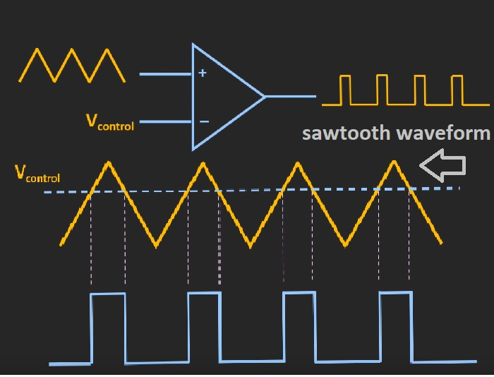

**Why is Pulse Width Modulation used?**

Pulse width modulation is an effective method that is used to control the amount of power delivered to a load without dissipating any wasted power.

**What are some applications of Pulse Width Modulation?**

Due to its high efficiency, low power loss and the ability of the PWM technique to precisely control the power, the technique is used in a variety of power applications:

They are used in telecommunication for encoding purposes.

They are used in Audio/Video amplifiers.

**Duty Cycle of PWM**

As we know, a PWM signal ON for a given time and stays OFF for a certain time. The percentage of time for which the signal remains ON is known as the duty cycle. If the signal is always “*ON,*” then the signal must have a 100 % duty cycle. The formula to calculate the duty cycle is given as follows:

Duty cycle = Turn on time/ (turn on time + turn of time)

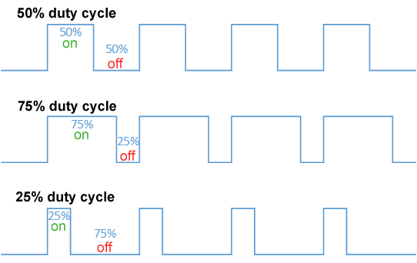

**What is the difference between the duty cycle and the frequency of a PWM signal?**

The frequency of a PWM signal describes how often the signal switches between high and low voltages. Frequency is expressed in the unit of Hertz. The duty cycle is the percentage of time the signal stays at a high voltage. It is expressed as the percentage of the period.

**Basic Architecture:**

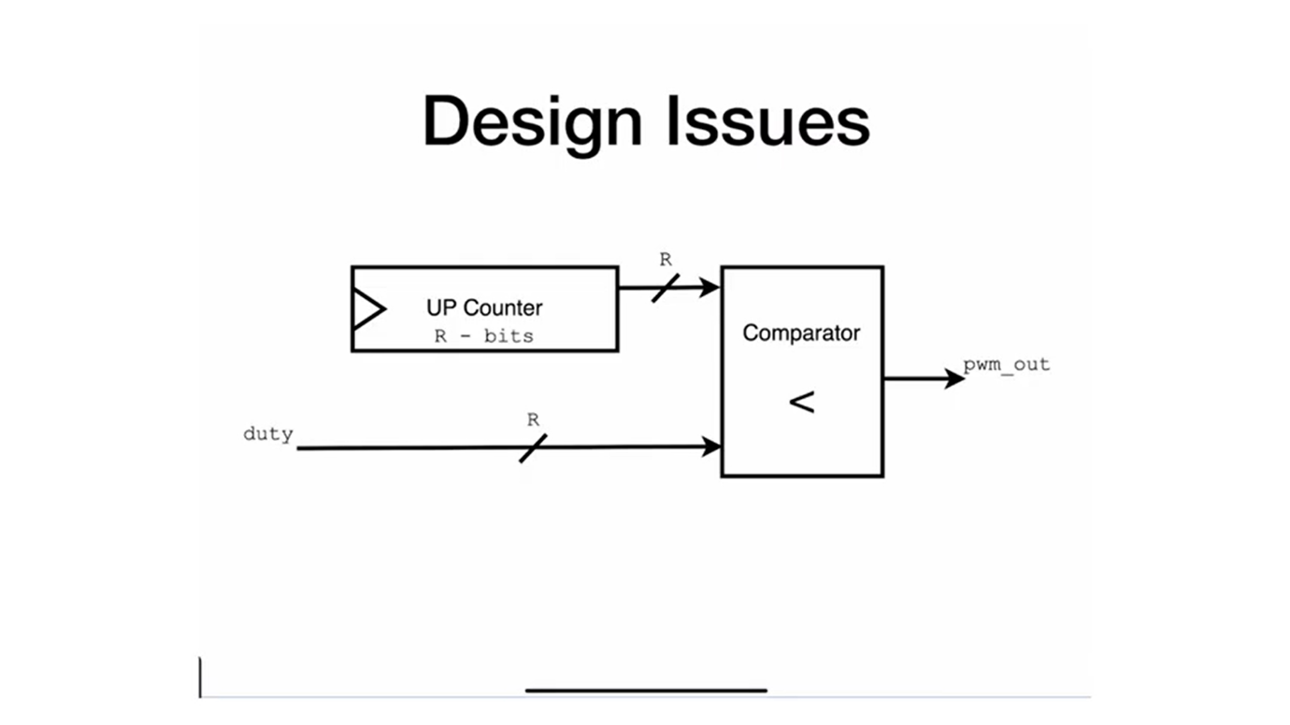

**Design:**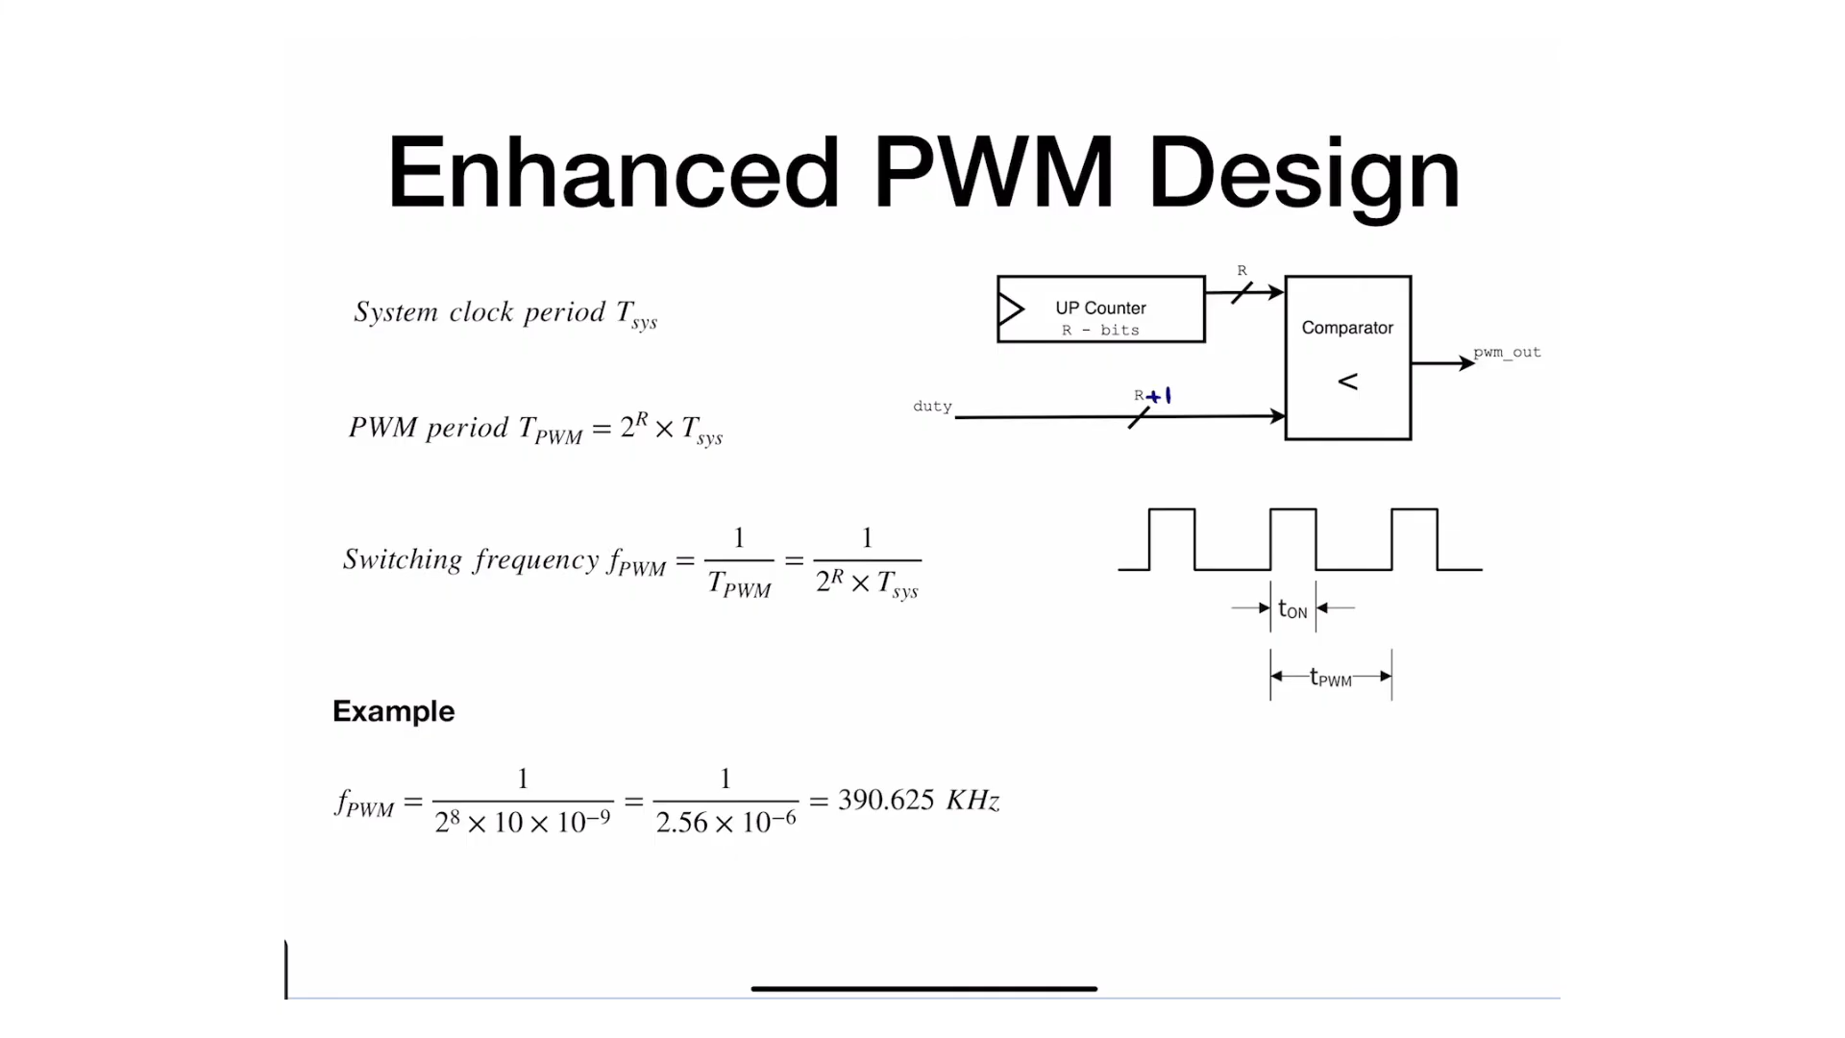

**Result:**

